Editorial Office
www.journalbinet.com
Email: info@journalbinet.com
JBAR - Journal of Bioscience and Agriculture Research
JSTEI - Journal of Science, Technology and Environment Informatics
IJBMSR - International Journal of Busines,Management and SocialResearch
JMSMR-Journal of Molecular Studies and Medicine Research

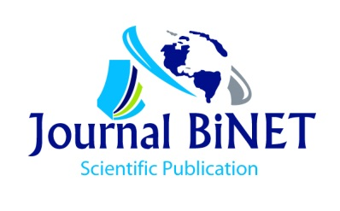

Copyright Transfer Agreement

To
Executive Editors

Title:.……………………………………………………………………………………………….............

……………………………………………………………………………………………………………...

Type of manuscript (research/review/case study/other): …………………………………………….......

All author names (as will be shown in published paper):..........................................................................
……………………………………………………………………………………………………………...
………....................................................................................................................................................

Corresponding author name, address, affiliation, email& mobile nr:...................................................
......................................................................................................................................................................
.......................................................................................................................................................................
The transfer of copyright gives JOURNAL BiNET the right to develop, promote, distribute, sell and archive a body of scientific works or articles throughout the world. The Author(s) hereby grants and assigns to JOURNAL BiNET all rights in and to Author’s Work and contributions. The Author(s) acknowledges that JOURNAL BiNET will have the right to print, publish, create derivative works, and sell the Work throughout the world, all rights in and to all revisions or versions or subsequent editions of the Work in all languages and media throughout the world. The author(s), reserve the following rights:
- All proprietary rights including copyrights, such as patent rights,
- The right to use all or part of this article, including tables and figures in future works of their own, provided that the proper acknowledgment is made to the Publisher as copyright holder on behalf of author(s), and
- The right to make copies of this article for his/her own use, but not for sale.
I/We, warrant and represent that the work does not violate any proprietary or personal rights of others (including, without limitation, any copyrights or privacy rights); that the Work is factually accurate and contains no matter libellous or otherwise unlawful; that I have substantially participated in the creation of the Work and that it represents my original work sufficient for me to claim authorship. Moreover, I/We agree and accept to abide editorial policy, terms of service, privacy policy, disclaimer and legal status/notice of JOURNAL BiNET. On behalf of all authors, I (Corresponding Author) declare that in cases of violation of applicable laws of any form and or ICT acts or any other disputes or conflicts, i will be responsible for any evolved/claimed costs, damage or repair, and I will pursue and or responsible for legal matters in the court by third party(s) or publisher(s). I further warrant and represent that I have no financial interest in the subject matter of the Work or any affiliation with an organization or entity with a financial/unethical interest in the subject matter of the Works and Published Article(s).

I/We have the consent of each author to transfer and assign any and all right, title and interest, including copyright of the article referenced above. I hereby assign and transfer copyright to the JOURNAL BiNET and all rights within the published work and or article. I/We confirm that this article or part of it has not been published elsewhere, nor is it under consideration for publication by any other publisher.

Signature:………………………………………………………………...Date: ………………………………………...

